Official league roster - Basketball
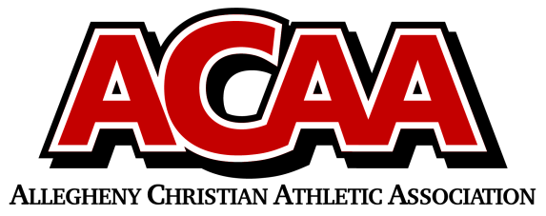

School Name: Johnstown Christian
Team Colors: royal blue and white
Overall Wins ___ Losses ____ Ties ___
ACAA Wins ___ Losses ____ Ties ___ OPPONENT: __________________________
Date: _________
Number | Name | Year | Position | Height | Homeschool
14 | Ellie Speigle | sr. | F
3 | Lydia Hostetter | sr. | G
12 | Sybella Mack | sr. | G
30 | Olivia Lushko | sr. | F
23 | Hope Ressler | jr. | C/F
22 | Malia Sorg | jr. | F/G
32 | Lily Lushko | Soph. | C/F
15 | Noel Lushko | Fr. | G
20 | Dani Colman | Fr. | F/G
2 | Oriana Yoder | Fr. | G
4 | Kendra Johnson | Fr. | F/G

Head Coach: Kevin Yoder
Asst. coach: Chris Lushko
Asst. coach:

Official ACAA League Team Roster. to be submitted to the scorer’s table before each game.

